Ho Chi Minh City University of Technology

*WEB PROGRAMMING*

*LAB 2.1 Create URLs with PHP*

Student: Nguyen Minh Hung – 2052504

Lecturer: Nguyen Duc Thai

FACULTY of COMPUTER SCIENCE and COMPUTER ENGINEERING

*Ho Chi Minh City, October 2023*

## Requirements

**LAB 2.1 Create URLs with PHP**Assume that link to your website is: **http://domain.com**Or locally **http://localhost/  
Assign links to buttons in Navigation bar (Horizontal Menu)**From previous layout, organize your buttons in horizontal navigation, such as:   
Assign links to above buttons as:   
http://localhost/index.php?page=home (URL 1)  
(default file: index.php)  
Similarly,  
http://localhost/index.php?page=products (URL 2)  
http://localhost/index.php?page=login (URL 3)  
http://localhost/index.php?page=register (URL 4)  
Make sure when you click on the links, some contents appear inside **body section** of   
the web page interface.  
When you click on URL 1, the browser loads home.php  
Similar with URL 2 and URL 3, browser loads products.php and login.php  
Note: You can include different files *.php inside the main interface, by using   
**include “filename.php**”;  
**Expected outcome: you complete the files:**• index.php  
• home.php  
• login.php  
• css + js files (*if needed*)

## Implementation

1. Home page

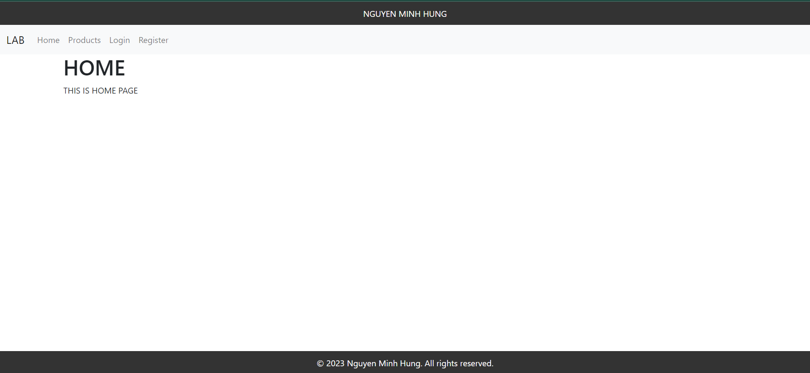

1. Product page

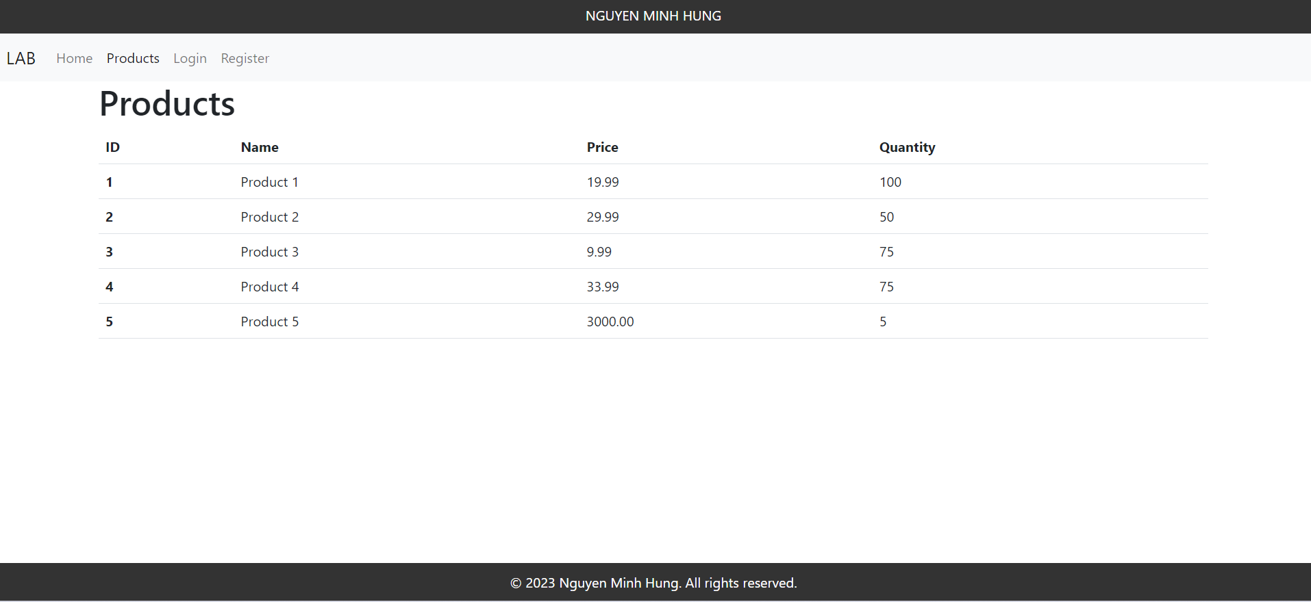

1. Login page

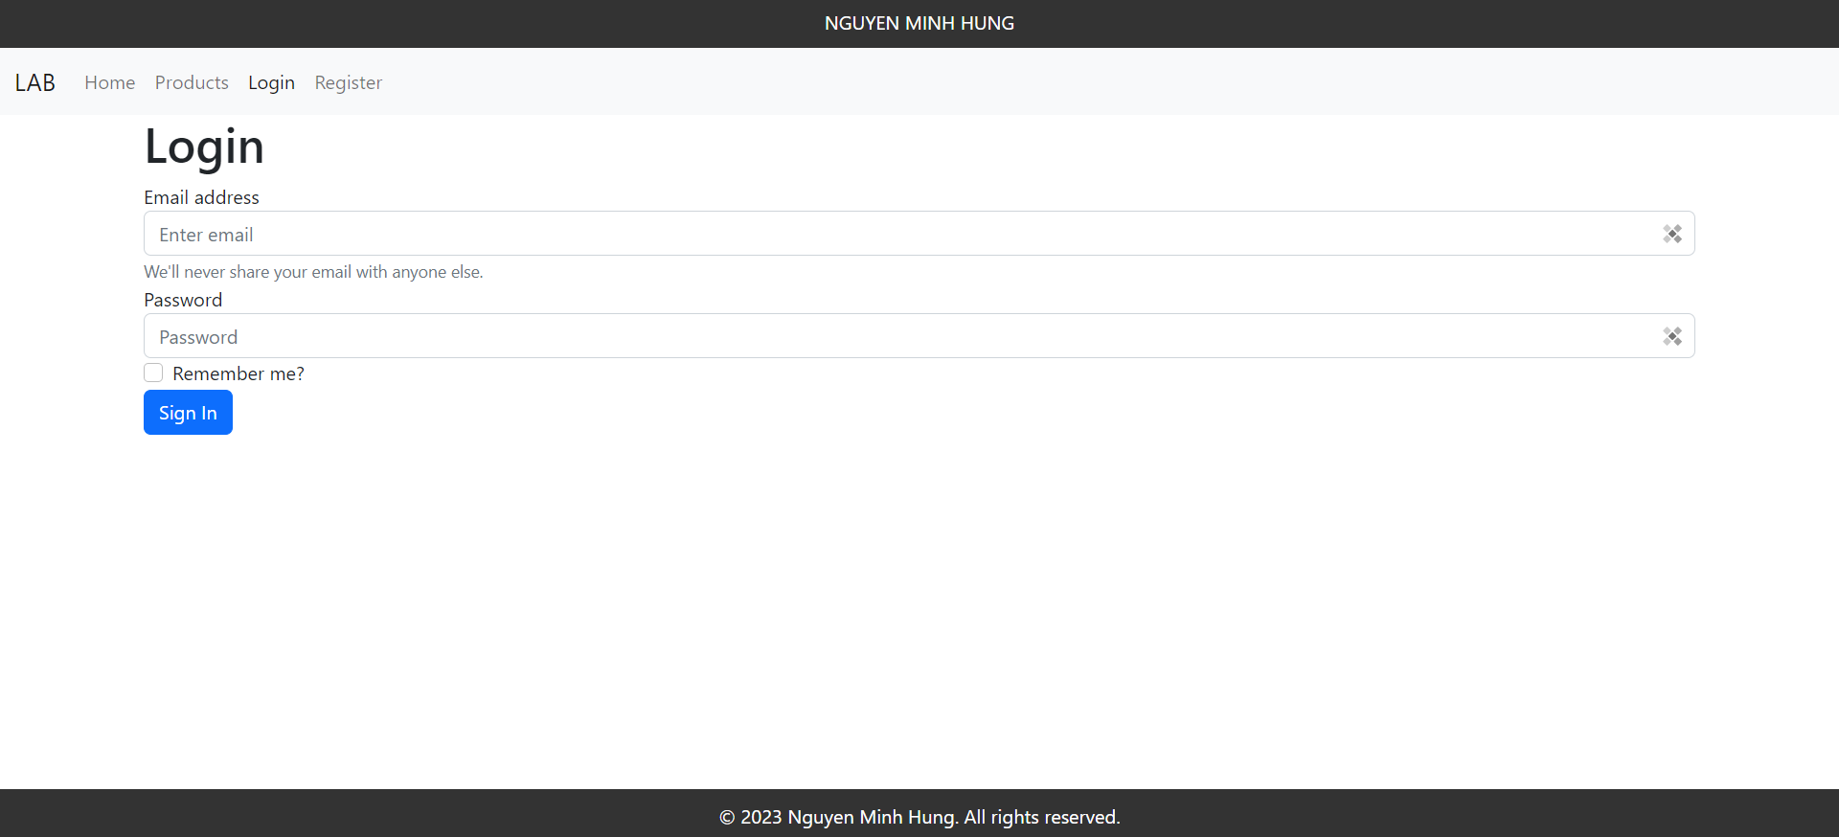

1. Register page

